Aero Ace Turning Mod:

Out of the box, the Aero Ace cannot turn without the throttle being on. Catch a good draft and you can loose your plane this way. By adding two diodes, you can have instant turning on demand without the use of the throttle.
The diodes used for this modification are 1N914/4148-Type Diodes (Radio Shack Part Number 276-122).
Start by unscrewing the transmitter antenna and remove. Next flip the transmitter over, and remove the four visible screws.
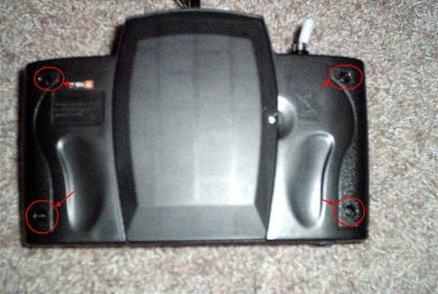
Remove the battery cover. There are three additional screws inside the the cover where the batteries go. Remove them.
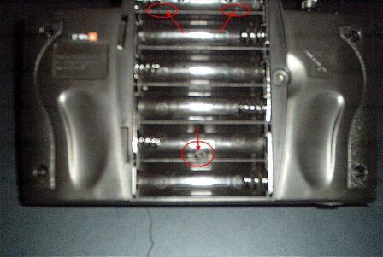
Slit the sticker where the antenna goes in. This will allow you to open the case. Remember that the case will open only so far, because of the charge cable!
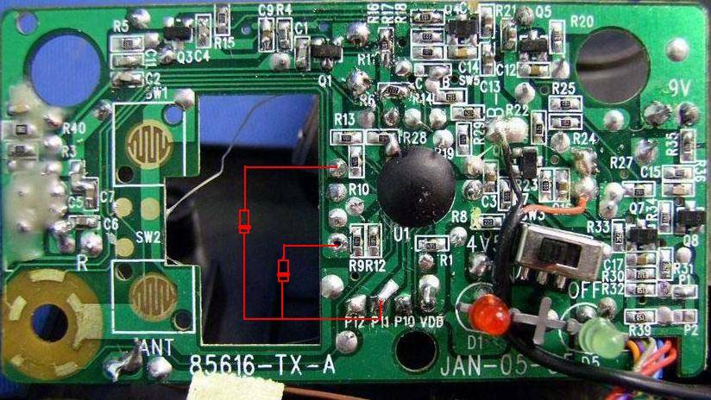
Take the diodes, and connect the banded end of both together then soldier. Carefully soldier to pad P11 as shown below. The other lead of each diode connects to the circle pads next to R9 and R10 as shown.
Note: You do not have to remove the board to perform this mod. To orientate yourself these points are located above the power switch near the steering control stick.
The diodes do not have to be flat against the circuit board, because the case top only goes down as far as the switch.
Verifying the mod works: Reassemble the case and antenna. Put the batteries in the transmitter and test by turning on the AeroAce and push the left and right stick one way then the other. Both motors should run, when the stick is pushed left or right. In one direction the motors may sound like they are running faster. This is normal. Now your ready to fly!

